What are the origins of the extreme flooding in Southeastern China?

Kylie Wong

Friday, March 1st, 2019



**Fig. 1** *Part of the Pearl River Delta that runs through the metropolitan city of Hong Kong in Southeast China (CD 2015).*

## Introduction

As China continues to climb up the global ranks with its recent goals for technological advancements and urban development, the natural landscape of the country is put at risk. Specifically in Southeast China, where urban development is centralized around the entire Pearl River Delta, large cities like Guangzhou and many others are at a high risk of flooding. As a result, the urban infrastructure is threatened (Kimmelman 2017). In addition, the entire livelihood of Chinese citizens are threatened with the high frequency of flash floods (Kimmelman 2017). The heavy rainfall and flooding in Southeast China in the summer of 2016 took 36 lives, left 200,000 people without a home, and caused over $1 billion in damages (CS 2016). The question now is: Will climate change escalate extreme weather trends, increase the frequency of these floods, and cost even more lives and more damages?

In this blog, I will explore the origins of the floods in the Pearl River Basin of South China, and what triggers the intensity of the floods. I evaluated the impacts of the floods on the socio-economic infrastructure of Southeast China. To address these questions, I tested 60 years of data for precipitation patterns across two different terrains in the Pearl River Basin.

#### How are floods and precipitation related?

Floods occur after heavy and overflowing rainfall on land that is usually dry. The most dangerous floods are flash floods, which are unpredictable and can flood an entire region in a short amount of time with high intensity (NSSL [date unknown]). A densely populated region with high development rates, like Southeastern China, would be extremely vulnerable to flash floods due to its lack of preparedness (Kimmelman 2017).

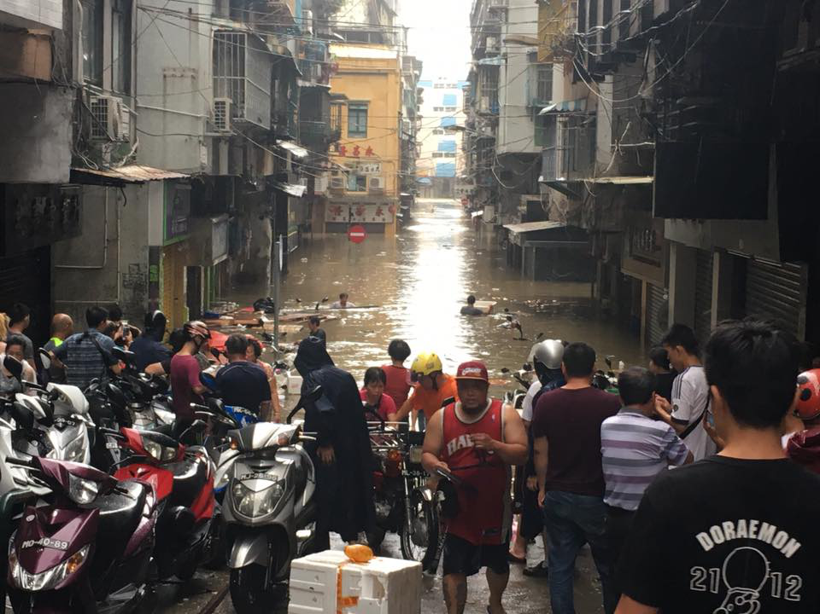

**Fig. 2** *Flooding in Macau in the less well-off part of town as a result of Typhoon Hato in 2017 (Pang 2017).*

## Methods

To conduct this study, I accessed the database on National Oceanic and Atmospheric Administration (NSSL [date unknown]) to collect precipitation data in my region of study. I collected data from: Guangzhou, the delta region in the eastern part of the basin, and Guilin, which is closest to the northwestern part of the basin. I chose to graph two different sets of data to test if the differences in the geographic terrain of the watershed is correlated with the amounts of precipitation in each region. I chose to use the data from August, because that data had the greatest variability and a more unique trend to analyze, coming from the height of the monsoon season between April and October of each year (H. Zhang et al. 2017).

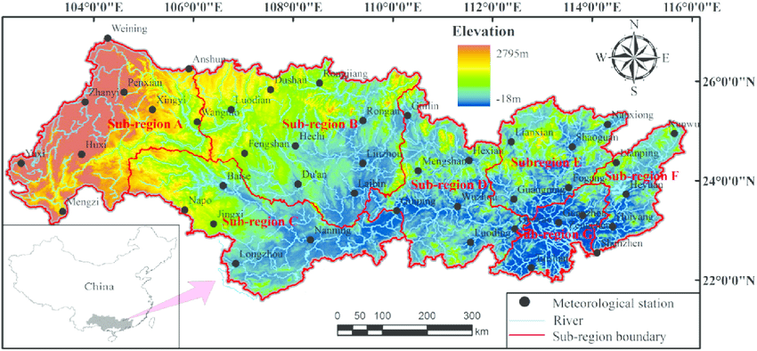

**Fig. 3** *Regions of the entire Pearl River Basin (Lai et al. 2015).*

To analyze the data, I will have to read and interpret the p and adjusted r2 values to ultimately test this null hypothesis: the precipitation levels of Pearl River Basin is dependent upon time. The significance of the p value and r2 value depends on how high the values are. To further the scope of my study, I accessed multiple peer review journals for the information about specific extreme climate patterns.

## Reading Precipitation Data

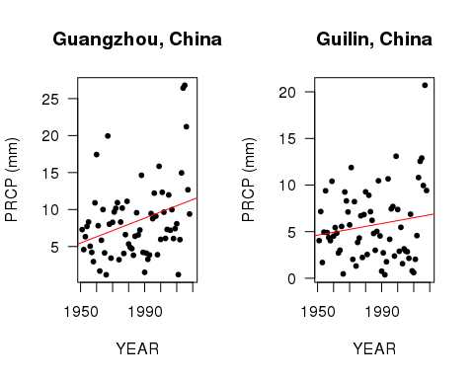

Fig.4 The graphs displayed above represents the precipitation averages for the month of August from each year between 1951 and 2018 for both Guangzhou and Guilin, China.

#### What do the graphs show?

For Guangzhou, China, we reject the null hypothesis (p value <0.01), concluding that the precipitation data has a weak relationship to the time of year. Less than 9% of the data is explanatory (adjusted r2 value is 0.0861).

For Guilin, China, we accept the null hypothesis (p value >0.05), which concludes that the trends of precipitation are related to the time of year. However, only about 1% of the data is explanatory (adjusted r2 value is about 0.01); therefore, the data for Guilin is very inconclusive and hard to explain.

#### What does this data mean?

Since the data from Guangzhou is much different than the data of Guilin, there must be other factors influencing the precipitation values. It is important to note that in the most recent 10 years, there have been some pretty high levels of precipitation in both Guangzhou and Guilin. This may be due to increased levels of climate change.

Although the regression lines are displaying an overall increase in precipitation over the years, the rainfall and statistical values are different. This is alarming, because to this day, we are still not sure what the cause of the variability is. I suspect that the difference in rainfall may be due to the differences in the terrain of Pearl River; however, this calls for research beyond the scope of my study.

## Discussion

#### What are the potential factors that result in this inconsistency and uncertainty in climate data?

*1. Seasonality:* One of the main reason that the climate data of Southeastern China is so inconsistent is due to the constant changes in seasonality and precipitation patterns. Scientists found that the frequencies of rainy days decreased, but the intensity increased throughout the Pearl River Basin (Q. Zhang et al. 2009). However, these patterns are found to be insignificant due to its variability and constant changes.

*2. Storms:* Another large factor that influences the precipitation patterns in the Pearl River Basin is the extreme climate events like [monsoons](https://en.wikipedia.org/wiki/Monsoon) and [typhoons](https://en.wikipedia.org/wiki/Typhoon) that are common in East Asia (Loo et al. 2015). These storms are also exacerbated by climate change. Unfortunately, even the intensity and effects of these storms vary seasonally, which increases the difficulty of having consistent data.

*3. El Niño-Southern Oscillation (ENSO):* [ENSO](https://en.wikipedia.org/wiki/El_Ni%C3%B1o%E2%80%93Southern_Oscillation) is not a popular phenomenon in the media; however, this series of irregular wind patterns and abnormal sea surface temperature is discovered to have significant effects on the tropical areas of the eastern Pacific Ocean, specifically my research region, Southern China (Niu 2013).

*4. Human activity:* Since the there is so much civilization and settlements around the entire river basin, humans have brought in much damage to the natural processes of the region. For example, “Human activities, such as land use, regulation, reservoir, may lead to monotonic change or trends in river discharge, however, we can still detect the climatic driving forces on interannual discharge variations” (Gu et al. 2017).



**Fig. 5** *Pollution and recreational activities in the Pearl River Delta in Hong Kong (Horwitz 2016).*

With so many factors in play, it is unclear what exactly leads to this increase of rainfall in the Pearl River Basin; therefore, it can be concluded that there are many uncertainties surrounding the origins of the floods. To further complicate this data, it is possible that the combination of these factors intensifies their individual consequences. For example, ENSO has an influence on the East Asian monsoons, which may exacerbate the overall impacts of extreme weather in Southern China (Niu 2013).

#### Why is this important?

Although we do not know exactly where the extreme flooding comes from around the Pearl River Basin, the effects of the flooding are unprecedented. The cities in the Pearl River Delta are especially susceptible to flooding due to its high population density and lowland region, facing a high rate of sea-level rise of 0.33-1cm per year (Yang et al. 2015). As displayed in the figure below, these cities are the most vulnerable to flooding, but have the least ability to adapt to changes in the region.

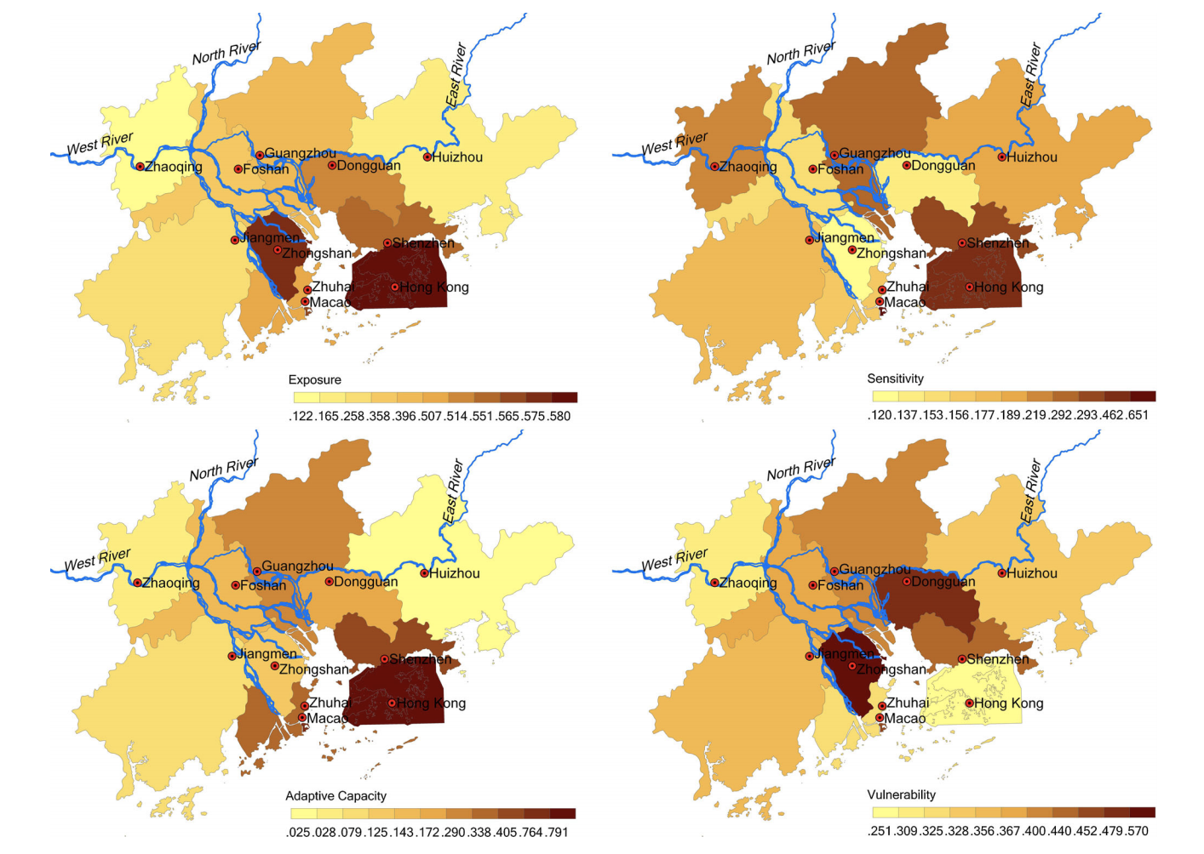

**Fig. 6** *An assessment of the relative vulnerability of different cities in the Pearl River Delta (Yang et al 2015).*

A city’s level of resilience to the extreme flooding is dependent upon risk identification, policy orientation, infrastructure construction, and socio-economic demographics (Yang et al. 2015). Communities based on agriculture around the Pearl River Basin would face harsh consequences as well, threatening the well-being of the farming communities and also harming food security in China (H. Zhang 2008); however, the purpose of my study remains focused on urban development. These continuous occurrences of flash flooding impose imminent threat to the economic and social well-being of various communities in Southern China, with the most unstable communities facing the greatest challenges in recovering.

## Conclusion: A call to action

#### What can be done moving forward?

The reason why many cities around the world, including a few cities in my research, has high adaptive capacities to extreme flooding, is because of adequate flood-control measures (Yang et al. 2015). I would like to suggest for the governments to enforce adequate flood-control measures along with investing in technologies to predict extreme weather patterns from the Pacific Ocean. Methods such as the 4-pronged “soft path” solution, which requires the integration of political, social, and scientific intervention, was proven to be effective in increasing the “floodwater retention capacity” and overall well-being of the inhabitants of the Yangtze River Basin (Pittock and Xu 2011).

Unfortunately, initiatives like these require large monetary investments and would not be upheld without action from the localities; therefore, I conclude that one of the most important components to gaining resilience and recognition in times of extreme climate events is activism amongst peoples of the localities and grassroot organizations, like the [All-China Environmental Federation (ACEF)](http://www.acef.com.cn/en/aboutacef/2013/1216/1004.html), to raise awareness for the human rights issues that come with environmental disasters.

Unless scientists–with the full support of government officials–conduct further research on what triggers an overall intensification of rainfall, all we can do now is to find possible solutions to mitigate as much human risk and flood hazards as possible under the changing climate.

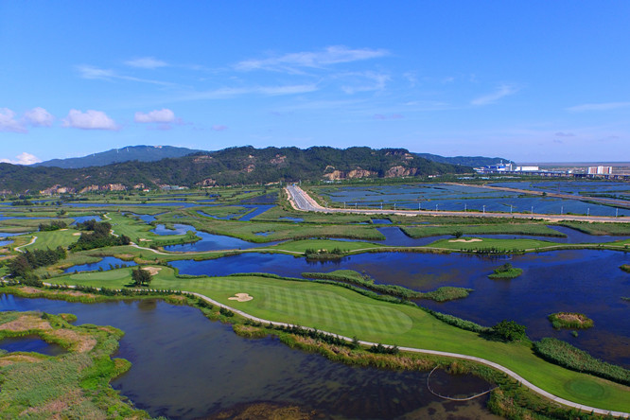

**Fig. 7** *Green landscape of the delta in Zhuhai, China (Pearl River Delta to build... 2016).*

### References

[CD] China Daily (CN). 2015. Pearl River Delta is world's largest urban area. China.org.cn.

[CS] Climate Signals Beta (US). 2016. China Floods June-July 2016. Climate Signals Beta.

Gu X, Zhang Q, Singh VP, Shi P. 2017. Hydrological response to large-scale climate variability across the Pearl River basin, China: Spatiotemporal patterns and sensitivity. Glob Planet Change. 149: 1-13.

Horwitz J. 2016. Here’s how huge amounts of trash from the Pearl River Delta washed up on Hong Kong’s shores. QUARTZ.

Kimmelman M. 2017. In the Pearl River Delta, breakneck development is colliding with the effects of climate change. The New York Times.

Lai C, Chen X, Wang Z, Zhao S, Wu X, Yu H. 2015. Spatial and temporal variations of rainfall erosivity on Pearl River basin during 1960-2012. Nongye Gongcheng Xuebao. 31(8):159-167.

Loo YY, Billa L, Singh A. 2015. Effect of climate change on seasonal monsoon in Asia and its impact on the variability of monsoon rainfall in Southeast Asia. Geosci Front. 6: 817-823.

Niu J. 2013. Precipitation in the Pearl River basin, South China: scaling, regional patterns, and influence of large-scale climate anomalies. Stoch Environ Res Risk Assess. 27: 1253-1268.

[NSSL] The National Severe Storms Laboratory. [date unknown]. Flood Basics. National Oceanic Atmospheric Association.

Pang J. 2017. 3 dead, 2 missing in Macau as Typhoon Hato leaves flooding and destruction in its wake. Hong Kong Free Press.

Pearl River Delta to build national forest city group by 2020. 2016. NewsGD.com

Pittock J, Xu M. 2011. Controlling Yangtze River Floods: A New Approach. World Resources Institute.

Yang L, Scheffran J, Qin H, You Q. 2015. Climate-related flood risks and urban responses in the Pearl River Delta, China. Reg Environ Change. 15:379–391.

Zhang H, Wu C, Chen W, Huang G. 2017. Assessing the Impact of Climate Change on the Waterlogging Risk in Coastal Cities: A Case Study of Guangzhou, South China. J Hydrometeorol. 18(6): 1549-1562.

Zhang H, Ma W-C, Wang X-R. 2008. Rapid Urbanization and Implications for Flood Risk Management in Hinterland of the Pearl River Delta, China: The Foshan Study. Sensors. 8(4): 2223-2239.

Zhang Q, Xu C-Y, Becker S, Zhang ZX, Chen YD, Coulibaly M. 2009. Trends and abrupt changes of precipitation maxima in the Pearl River basin, China. Q. J. Royal Meteorol. Soc. 10(2):132 - 144